[Testing] - Checklist

MAIA QA Testing Framework
Version: v0.2
Owner: Product / Implementation Team
Purpose: Internal QA gate — complete this before any client handover or UAT session
Environment: Staging or dedicated QA instance with real client data loaded

How to Use
- Mark each item: ✅ Pass · ❌ Fail · ⚠️ Flag (works but behaviour is unexpected — escalate)
- If anything is ❌ Fail — stop, log it, fix it. Do not proceed to the next section.
- ⚠️ Flag items do not block progress but must be reviewed before final sign-off.
- One person runs this. A different person reviews and countersigns. No self-approval.
- Sections marked (If in scope) — skip only if explicitly confirmed out of scope for this deployment. Write "N/A — [reason]" in the notes column, not just a blank.

Deployment Details (Fill Before Starting)
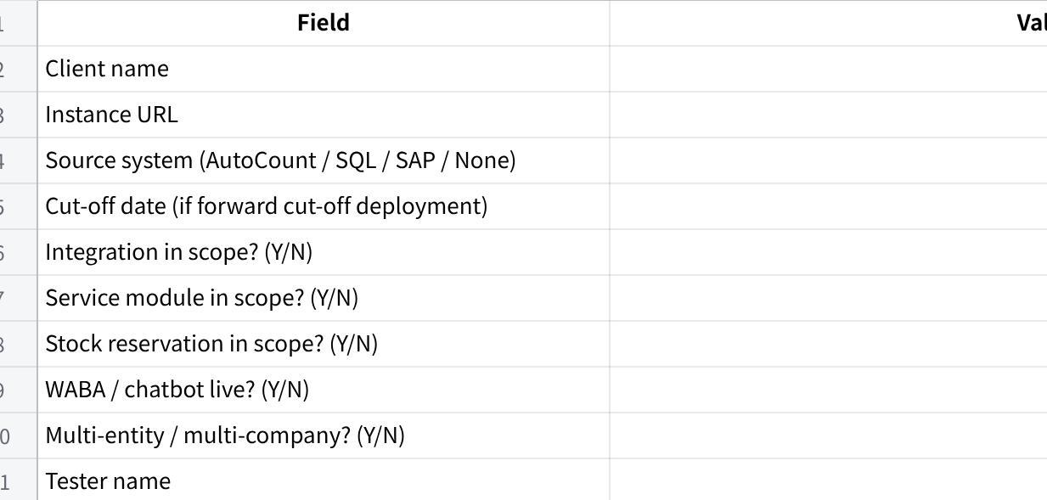
点击图片可查看完整电子表格

Section 0 — System Configuration
These are the foundational settings that everything else depends on. Wrong config here means every test below this is testing on a broken foundation.

0.1 Company Setup
- [ ] Company legal name is correct and matches SSM registration
- [ ] Default currency is MYR (or confirmed correct for the client)
- [ ] Fiscal year start and end dates are correct
- [ ] Company logo is uploaded and displays correctly on document PDFs
- [ ] Company address, phone, email, and registration number are correct on document headers
- [ ] If multi-entity: all companies are created, each with their own correct legal name, currency, and fiscal year
- [ ] Inter-company transactions are configured correctly (if applicable)

0.2 Tax Configuration
- [ ] Tax template(s) are configured (SST 8%, SST 6%, exempt — whatever applies to this client)
- [ ] Default tax is applied correctly on QT, SO, and SI line items
- [ ] Tax-exempt items are correctly flagged and do not attract tax on documents
- [ ] Tax registration number appears correctly on Sales Invoice PDF

0.3 Numbering Series
- [ ] Document numbering series are configured for all doctypes in scope:
- [ ] cRFQ (if in scope)
- [ ] Quotation
- [ ] Sales Order
- [ ] Sales Invoice
- [ ] Delivery Note
- [ ] Pick List
- [ ] Payment Entry
- [ ] Credit Note / Debit Note
- [ ] SWO (if service module in scope)
- [ ] Numbering series format matches client's preferred format (e.g. INV-2025-0001, not ERPNext default)
- [ ] Series do not clash with existing document numbers in the client's source system — confirm prefix is distinct

0.4 Payment Terms
- [ ] All payment terms used by the client are configured (e.g. Net 30, Net 60, COD, CIA)
- [ ] Payment terms produce correct due dates when applied to a Sales Invoice
- [ ] Default payment term is set at company level

0.5 Currency & Exchange Rate
- [ ] MYR is the base currency
- [ ] If the client transacts in foreign currencies: USD, SGD, or others are configured
- [ ] Exchange rates are set and up to date
- [ ] Foreign currency invoices display correctly with both foreign and base currency amounts

0.6 User Accounts & Role Assignment
- [ ] Every live user account is created with their correct name and email
- [ ] Each user is assigned the correct role(s) — no over-permissioning
- [ ] Each user is scoped to the correct company via UserPermission (multi-entity deployments)
- [ ] No user has System Manager access unless explicitly authorised
- [ ] Shared/generic logins do not exist — every account is person-specific

0.7 Workflow Configuration (If configured)
- [ ] Approval workflows are active on the correct doctypes (QT, SO, or both — per client config)
- [ ] Only one active workflow per doctype — confirm no duplicate workflows exist
- [ ] workflow_state field is used — not competing with ERPNext native status
- [ ] Workflow transitions are correctly defined: who can approve, who can reject, what state each action leads to
- [ ] Rejected documents route back to the submitter with the reason visible

0.8 Notification & Digest Configuration
- [ ] Notification rules are configured per the notification serving protocol
- [ ] Working hours are set correctly for the client's timezone
- [ ] Daily digest schedule is configured and set to the correct delivery time
- [ ] WABA channel is linked to the correct phone number (if in scope)
- [ ] In-app notification fallback is active for users without WABA

Section 1 — Master Data: Row Counts & Integrity
Garbage in, garbage out. The most boring section and the most important. Row count checks come first — if the numbers don't add up, spot-checking individual records is pointless.

1.1 Row Count Reconciliation
Before checking any individual record, verify total record counts match between source system and MAIA. Get these numbers from the client's source system export or the integration sync log.
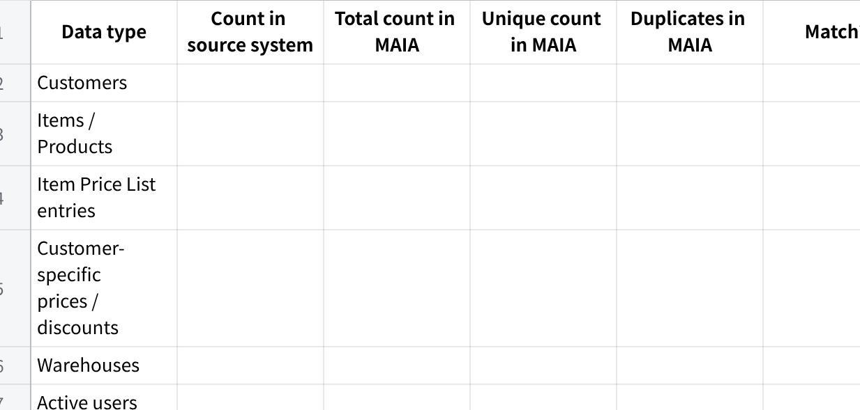
点击图片可查看完整电子表格
How to get unique count and duplicates in MAIA: Run a report or query grouped by the unique key (customer code, item code, etc.) and count records with more than one occurrence. Duplicates must be resolved before proceeding — they cause silent data corruption on every transaction that touches the affected record.
- [ ] Total count in MAIA matches source system — tolerance: zero
- [ ] Unique count equals total count — if these differ, duplicates exist and must be resolved before proceeding
- [ ] Zero duplicate customer codes in MAIA
- [ ] Zero duplicate item codes in MAIA
- [ ] Zero duplicate price list entries for the same item + price list combination
- [ ] Zero duplicate customer-specific price entries for the same customer + item combination
- [ ] If any count does not match or duplicates exist: do not proceed. Find the gap or duplicate, fix the import, recount.

1.2 Customer Master
Completeness — spot-check 5 customers from different segments:
- [ ] Full legal name matches source system exactly — no truncation, no abbreviation
- [ ] All billing addresses are present and correctly formatted
- [ ] All shipping / delivery addresses are present — if the customer has multiple delivery points, all must be selectable on documents
- [ ] All contacts are present: primary contact (name, phone, email), plus secondary contacts (AP, operations) if the client tracks them
- [ ] Payment terms are set and match source system
- [ ] Customer group / category is assigned — if missing, tiered pricing will fall back incorrectly
- [ ] Tax ID / SST registration number is present (if applicable)
Integration code check (AutoCount / SQL deployments):
- [ ] Customer code in MAIA matches source system exactly — including leading zeros and format (e.g. C00123 not C123)
- [ ] Pull 5 customers at random. Compare codes side by side. All 5 must match exactly.
Credit exposure — spot-check at least 3 customers with outstanding balances:
Forward cut-off deployments: Balances are not live-synced. They are represented by two manually created opening balance invoices per customer, dated as at the agreed cut-off date:
- Invoice 1 — Current outstanding: total open invoices not yet overdue at cut-off
- Invoice 2 — Overdue: total overdue amount at cut-off, backdated so aging buckets (30/60/90 days) are correct
Without these, credit limit checks are meaningless from day one.
- [ ] Credit limit in MAIA matches source system exactly
- [ ] Opening balance invoices exist for every customer with an outstanding balance (current + overdue split)
- [ ] Invoice amounts match source system export at cut-off date — tolerance: zero
- [ ] Overdue invoice is backdated correctly — aging buckets calculate accurately from go-live
- [ ] Combined exposure (opening invoices + new MAIA invoices) displays correctly in the customer credit view
- [ ] Customer with a hold/block in source system shows the same status in MAIA
- [ ] Customer with zero balance shows zero — no false positive block

1.3 Item Master
Completeness — spot-check 10 items across different categories:
- [ ] Item code matches source system exactly — same format, same leading zeros
- [ ] Item name / description matches source system (clients notice this immediately)
- [ ] Item group / category is assigned
- [ ] item_type is correct: Product for inventory items, Service for service items
- [ ] Reorder / minimum stock level is set (if client tracks this)
Integration code check (AutoCount / SQL deployments):
- [ ] Item code in MAIA matches source system exactly
- [ ] Pull 10 items at random. Compare codes. All 10 must match.
UOM:
- [ ] Base UOM is correct for each item (e.g. KG, PCS, BOX)
- [ ] All secondary UOMs are configured for items sold or purchased in multiple units (e.g. item sold as PCS but purchased as CTN)
- [ ] UOM conversion factors are correct — if 1 CTN = 12 PCS, that must be in MAIA exactly. Wrong conversion factors silently corrupt every quantity calculation downstream.
- [ ] Spot-check 5 items with multiple UOMs: verify conversion factors against source system or physical pack size
Stock / Inventory:
- [ ] Opening stock quantity per warehouse matches source system export at cut-off date
- [ ] Stock is linked to the correct warehouse
- [ ] actual_qty and available_qty are visible and correct
- [ ] reserved_qty is visible (if stock reservation is in scope)
- [ ] Zero-stock items exist as item records showing 0 — they must not be missing from MAIA

1.4 Pricing & Price Lists
- [ ] Standard price list is created and named correctly
- [ ] Every item that has a price in source system has a corresponding price in MAIA's standard price list — use row count from §1.1 to confirm completeness
- [ ] Spot-check 10 item prices: prices in MAIA match source system exactly (amount and currency)
- [ ] If the client has multiple price lists (e.g. retail, wholesale, distributor): all price lists are configured in MAIA
- [ ] Each price list is assigned to the correct customer group or individual customer
Customer-specific pricing and discounts:
- [ ] Customer Item Price entries exist in MAIA for every customer-specific price override that exists in source system — use row count from §1.1 to confirm completeness
- [ ] Spot-check 5 customer-specific prices: verify the override price in MAIA matches what the client has configured in AutoCount/SQL
- [ ] Customer discounts (if client uses discount % instead of override price) are configured and apply correctly on QT line items
- [ ] When creating a QT for a customer with a special price, the special price auto-applies — the standard price does not appear first
- [ ] When creating a QT for a customer with no special price, the standard price list price applies

1.5 Warehouse Structure
Rule: Warehouse structure in MAIA must mirror the client's physical and system structure. Do not rename or consolidate warehouses without explicit client approval.
- [ ] If client has named warehouses in source system: the same names exist in MAIA
- [ ] If client has no warehouse structure (MAIA standalone): MAIA default warehouse structure is applied — document which default was used
- [ ] Each warehouse is linked to the correct company (critical for multi-entity deployments)
- [ ] Warehouse codes match source system codes exactly (AutoCount / SQL deployments)
- [ ] Items are linked to the correct warehouse — an item stocked in Penang Store must not show as stocked in Main Warehouse
- [ ] Stock levels per warehouse are correct — if client tracks stock by location, the split must be accurate

Section 2 — Role & Permission Isolation
Test this with actual role-specific logins. Do not test by toggling permissions in admin view — that is not what the user experiences.

2.1 Sales User
- [ ] Can create: cRFQ, CPO, Quotation, Sales Order
- [ ] Cannot access: Sales Invoice, Payment Entry, Pick List creation
- [ ] Cannot see records belonging to other companies (multi-entity deployments)

2.2 Sales Manager
- [ ] Can see approval queues: cRFQ, Quotation, SO (per workflow config)
- [ ] Can approve — document transitions to correct next state
- [ ] Can reject with reason — document returns to Sales User with reason visible

2.3 Finance User
- [ ] Can access: Sales Invoice, Debit Note, Credit Note, Payment Entry, Payment Receipt, Payment Voucher
- [ ] Cannot create or edit: Sales Order, Pick List, Delivery Note

2.4 Logistics User
- [ ] Can access: Pick List, Delivery Note, Delivery Trip, Shipment
- [ ] Cannot access: Sales Invoice, Payment Entry, customer credit data

2.5 Warehouse User
- [ ] Can view and update Pick List (confirm actual picked quantities)
- [ ] Cannot access: financial documents, customer pricing, credit data

2.6 Driver
- [ ] Can view assigned Delivery Trip stops only
- [ ] Can record POD / POP
- [ ] Cannot access any document outside their assigned trips

2.7 Service Coordinator (If service module in scope)
- [ ] Can create, assign, schedule, and complete SWO
- [ ] Cannot access: financial documents, pick lists

2.8 Cross-Entity Isolation (If multi-entity)
- [ ] User scoped to Company A cannot see Company B records in any list view, report, or chatbot query
- [ ] No cross-entity data leakage

Section 3 — Sales Flow: Inventory Path
Run this end-to-end. Every document must be created and submitted — do not assume a step works because the previous one did.

3.1 cRFQ (If in scope)
- [ ] Create a new cRFQ, attach a sample file (PDF or image)
- [ ] AI extraction runs and populates draft line items
- [ ] Line items are reviewable and editable by the user
- [ ] Status transitions correctly: Open → Drafting → Draft Ready → Under Review → Quotation Issued
- [ ] Quotation is generated from cRFQ and linked back to it
- [ ] Clarification questions surface on the cRFQ form and can be answered

3.2 CPO Upload
- [ ] Upload a sample customer PO document
- [ ] AI extracts: customer, items, quantities, requested delivery date
- [ ] Extracted line items can be matched to existing items in MAIA
- [ ] CPO converts to Quotation (match/review path) OR directly to Sales Order (CPO direct path) — confirm which path is configured

3.3 Quotation
- [ ] Create a Quotation manually (not from cRFQ or CPO)
- [ ] Customer-specific price auto-applies on line items where configured
- [ ] Null-price item blocks QT submission — notification fires to the correct person
- [ ] Quotation PDF generates correctly: company header, logo, customer address, line items, totals, T&Cs

3.4 Sales Order
- [ ] Convert Quotation to SO (QT Won path)
- [ ] Create SO directly from CPO (CPO direct path)
- [ ] SO shows: per_delivered, per_billed, per_fulfilled
- [ ] SO Confirmation PDF generates correctly

3.5 Pick List
- [ ] Generate Pick List from SO
- [ ] Pick List shows correct items, quantities, warehouse
- [ ] Warehouse user can update actual picked quantities
- [ ] Pick List marked complete — DN creation is triggered

3.6 Delivery Note
- [ ] Create DN from Pick List — quantities reflect actual picked, not SO quantities
- [ ] Create DN directly from SO (no Pick List path) — confirm this path works
- [ ] DN submission updates per_delivered on SO
- [ ] Delivery Note PDF generates correctly

3.7 Delivery Trip (Self-deliver)
- [ ] Create Delivery Trip, add DN as a stop, assign driver
- [ ] Driver can view their trip stops in their own login
- [ ] Driver records POD — delivery confirmed
- [ ] Delivery Checklist PDF generates correctly

3.8 Shipment (3PL path)
- [ ] Create Shipment from DN
- [ ] Airway Bill generates correctly
- [ ] Shipment status updates correctly on DN

3.9 Sales Invoice
- [ ] Create SI from SO
- [ ] SI line items match SO — no phantom additions, no missing lines
- [ ] Customer-specific price is preserved on SI (not reverted to standard)
- [ ] Tax applies correctly
- [ ] SI submission updates per_billed on SO
- [ ] Invoice PDF generates correctly

3.10 Payment Entry (Receive)
- [ ] Create Payment Entry (payment_type = Receive)
- [ ] Payment allocates correctly to the outstanding SI
- [ ] Payment Receipt PDF generates
- [ ] Customer outstanding balance updates after payment

Section 4 — Sales Flow: Service Path (If in scope)
- [ ] Create SO with item_type = Service line item
- [ ] SWO is created and linked to the SO
- [ ] Service Coordinator can assign technician and set schedule
- [ ] Job Sheet generates correctly for the technician
- [ ] Technician can view their assigned SWO in their own login
- [ ] SWO marked complete — per_fulfilled updates on SO
- [ ] If parts consumed: Stock Entry (Material Issue) reduces inventory correctly
- [ ] SI can be created from SO after SWO completion

Section 5 — Amendment & Returns Flow

5.1 Sales Return
- [ ] Create Return Note from existing DN (is_return = 1)
- [ ] Return Note is linked to original DN
- [ ] Credit Note created from Return Note — amounts are correct
- [ ] Payment Entry (payment_type = Pay) created for refund — Payment Voucher generates

5.2 Billing Amendments
- [ ] Create Debit Note from submitted SI (additional charge)
- [ ] Create Credit Note from submitted SI (correction / reduction)
- [ ] Both PDFs generate correctly

5.3 Cancel & Amend
- [ ] Cancel a submitted QT — confirm downstream documents handle the cancellation
- [ ] Cancel a submitted SO — confirm linked DNs and SIs handle the cancellation
- [ ] Amend creates a new draft (docstatus = 0) with reference to the original
- [ ] Resubmit amended document — status transitions correctly

Section 6 — Exception & Approval Flows

6.1 Credit Limit Breach
- [ ] Create a SO for a customer at or above their credit limit
- [ ] Credit check fires — correct block or flag behaviour
- [ ] Notification routes to the correct approver (Finance / Credit Controller)
- [ ] Approver can approve with reason — order proceeds
- [ ] Approver can reject with reason — document returns to Sales User
- [ ] Audit trail records who approved/rejected and when

6.2 Null-Price Block
- [ ] Attempt to submit a QT with a null-price item — block fires
- [ ] Notification routes to the pricing/purchasing owner
- [ ] Pricing owner sets the price — Sales User is notified
- [ ] QT can now be submitted with price confirmed
- [ ] Audit trail shows price was set after initial block

6.3 Approval Workflow
- [ ] Submit a document requiring approval (QT or SO — per config)
- [ ] Approver receives notification
- [ ] Approver approves — document transitions to correct next state
- [ ] Approver rejects with reason — document returns to submitter
- [ ] Rejected document shows the rejection reason to the submitter

6.4 Stock Reservation (If in scope)
- [ ] Create a stock reservation for a specific item and customer
- [ ] Available-to-sell quantity reduces correctly
- [ ] A second user cannot over-reserve beyond available stock
- [ ] Reservation can be released — available-to-sell restores
- [ ] Stale reservation alert fires after the configured hold threshold

Section 7 — Notifications & Chatbot

7.1 Notification Delivery
- [ ] Submit a document that triggers a notification — notification received on the correct channel
- [ ] Notification content is correct: doctype, reference number, amount, customer name
- [ ] Critical events (credit breach, approval rejection) fire immediately — not batched
- [ ] Non-critical events batch correctly into Summary at phase transitions
- [ ] Daily digest delivers at the configured time with role-appropriate content
- [ ] Outside working hours: non-critical notifications are held, not sent
- [ ] Critical events bypass working hours and send immediately

7.2 Chatbot Queries
- [ ] Stock check: correct quantity returned for the queried item
- [ ] Price check: correct price returned, including customer-specific price where applicable
- [ ] Credit check: correct outstanding balance and credit limit returned
- [ ] Invoice retrieval: correct document returned by reference number
- [ ] Query for another company's data returns nothing / access denied — no cross-entity leakage

Section 8 — Integration Layer (If in scope)
Integration failures are silent killers. A push that silently fails is worse than one that errors — nobody knows the data didn't land.

8.1 Master Data Sync (Source ERP → MAIA)
- [ ] Create a new customer in source ERP — appears in MAIA within sync window
- [ ] Update an item price in source ERP — price updates in MAIA within sync window
- [ ] Update stock level in source ERP — stock level updates in MAIA within sync window
- [ ] Sync log is visible and shows last successful sync timestamp

8.2 Transactional Push (MAIA → Source ERP)
- [ ] Submit SO in MAIA — accepted and visible in source ERP
- [ ] Submit DN in MAIA — accepted in source ERP
- [ ] Submit SI in MAIA — accepted in source ERP
- [ ] Submit Payment Entry in MAIA — accepted in source ERP
- [ ] Submit Credit Note in MAIA — accepted in source ERP

8.3 Error Handling
- [ ] Deliberately trigger a failed push (e.g. item code that doesn't exist in source ERP) — MAIA surfaces an error, does not silently drop it
- [ ] Failed sync items are logged and visible to an admin
- [ ] Retry mechanism works — failed push retries without manual intervention
- [ ] After retry succeeds, the record is no longer in the failed queue

Section 9 — Document Output Quality
Clients see the PDFs, not the database. A correct record with a broken PDF is a day-one complaint.
For each document, generate a PDF and review it visually against this checklist:
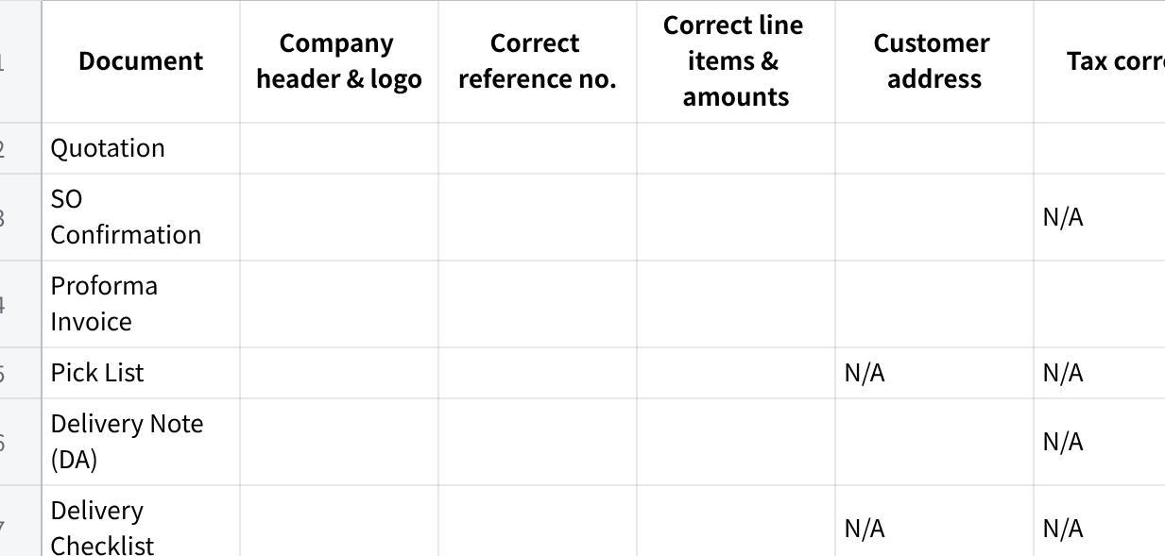
点击图片可查看完整电子表格

Section 10 — Data Integrity & Edge Cases
- [ ] Create two SOs for the same customer simultaneously — no collision, both process correctly
- [ ] Cancel a submitted document — all downstream documents linked to it handle the cancellation without errors
- [ ] per_delivered on SO updates immediately and correctly after DN submission
- [ ] per_billed on SO updates immediately and correctly after SI submission
- [ ] per_fulfilled on SO updates correctly after SWO completion (service) or DN (inventory)
- [ ] Fully fulfilled and fully billed SO transitions to the correct closed/completed status automatically
- [ ] Search and retrieve any submitted document by: document number, customer name, date range
- [ ] Audit trail on every submitted document shows: created by, submitted by, timestamp

Section 11 — Adoption Readiness
- [ ] Sales User can create a Quotation entirely from a mobile browser — no desktop required
- [ ] Chatbot interactions work correctly on WhatsApp (if WABA is live)
- [ ] No form takes more than 3 seconds to load on a normal connection
- [ ] List views show relevant records by default — no user sees a blank screen on first login
- [ ] Notification links are actionable — tapping a link goes directly to the relevant document
- [ ] At least one real user from each role has logged in, completed a test transaction, and confirmed it makes sense to them

Final Sign-Off
All sections must be complete. Partial sign-off is not valid. Write "N/A" with a reason for any skipped section.
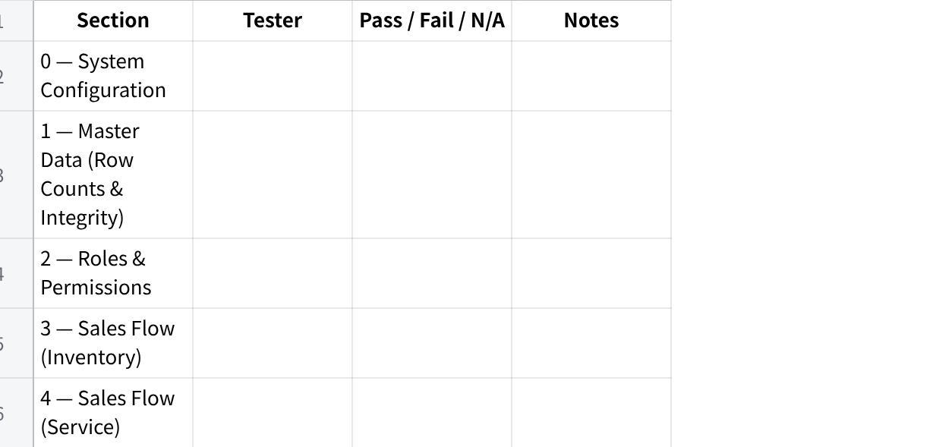
点击图片可查看完整电子表格
QA Tester: _________________________Reviewer: _________________________Date completed: _________________________Client / Instance: _________________________Overall result: ☐ Ready for UAT ☐ Not ready — open failures logged

Known Exclusions
The following are out of scope for this internal QA pass:
- Client-specific UAT test scenarios (covered in per-client UAT protocol)
- Performance / load testing
- Security / penetration testing
- Historical data migration validation (covered in separate migration acceptance checklist)
- WABA channel setup and number verification (covered in onboarding channel setup guide)

MAIA QA Testing Framework v0.2 — Mindhive Internal Use Only

